Don’t

Tell

me

Preface

Purpose is to destroy the decorative idea which has been presented in every corner of society in India. Class is view of thought English people rule this country and country got freedom from the British. To my view many people can take objection, I want to know from their’s thought what has been their idea of freedom.

Freedom is not just idea, it has be to made to action, why somebody very much interested in controlling your freedom.

Freedom is for what to express or state what is being actual to have been happened at some point of time. Freedom to express to recognize only the facts. In short

We are told that Hedgewar joined the call of the 1929 Lahore Congress that on each January 26, National Flag; the Tricolour should be unfurled publicly. RSS under the command of Hedgewar refused to follow it. Instead  he ordered on January 21, 1930 to all the RSS shakhas to worship "rashtriye dhwaj arthat bhagwa dhwaj (national flag i. e. saffron flag)". This order is available in a collection of Hedgewar's letter published by RSS titled Dr. Hedgewar: Patrroop Veyaktidarshan, published in 1981.

the RSS English organ Organizer in its issue of August 14, 1947, denigrating the National Flag wrote that it would "never be respected and owned by Hindus. The word three is in itself an evil, and a flag having three colours will certainly produce a very bad psychological effect and is injurious to a country."

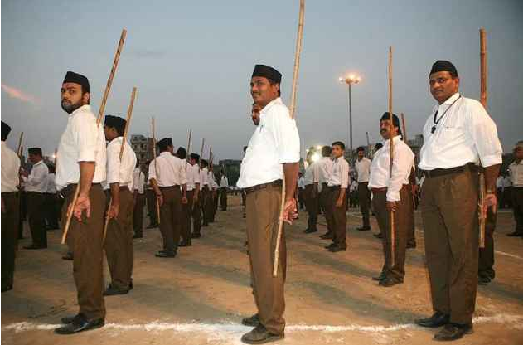

https://www.outlookindia.com/website/story/constructing-rss-role-in-the-freedom-struggle/308342